FOR SALE • Single Family Residence | $2,250,000

31880 Aliso Canyon Rd • Acton 93510 | 11 days on the market

5 beds, 2 baths • 2,628 sqft • 6,470,402 sqft lot • $856.16/sqft • Built in 1915 | Listing ID: SR17062108

Soledad Canyon to Aliso Canyon property is on the left side

 | 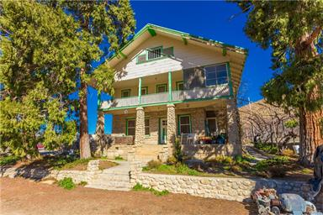  1 / 32 | 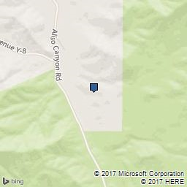

Beautiful Historic Blum Ranch! 5 bedroom 2 bath 2628 sq.ft home on approx. 150 acres. Home is constructed from custom cut stone with handcrafted wood work through-out.Established in 1915 it is a rare beauty.Home has large kitchen with wood stove,all bedrooms are good size with 4 upstairs and one down. Beautiful living room with two stain glass windows and fireplace with blaze king insert. There is also a 3 bdrm, 1 bth guest house,packing shed,with sorting machinery, walk-in 2 room refrigerator,approx. 23 acres with peaches,pears and lilacs,store,1 car garage,horse facilities,seasonal creek frontage with water rights and multiple wells on the property. This is truly an unique property with endless possibilities.Please call agents with questions or for a private showing.

Last updated on 03/29/2017 7:05:15 AM
Facts & Features

  • Listed on 03/23/2017
  • Original List Price of $2,250,000
  • Levels: Three Or More
  • 1 Garage spaces
  • 1 Total parking spaces
  • Laundry: See Remarks
  • Cooling: See Remarks
  • Heating: Central Furnace
  • Fireplace: Guest House, Kitchen, Living Room, Wood, Wood Stove Insert, Free Standing, See Remarks
  • Patio: Enclosed, Porch - Front, Porch - Rear
  • Pool: Private, In Ground, See Remarks
  • View: Creek/Stream, Mountain, See Remarks

Interior
  • Rooms: Basement, Family Room, Main Floor Bedroom, Master Bedroom, Sun, Workshop
  • Eating Area: Dining Room, In Kitchen
  • Appliances: Dishwasher, Electric Range

Exterior
  • Lot Features: Agricultural - Row/Crop, Agricultural - Tree/Orchard, Horse Property, Over 40 Units/Acre
  • Waterfront Features: Creek
  • Sewer: Cesspool, Conventional Septic

Additional Information
  • Standard sale
  • No association dues
  • Acton-Agua Dulce Unified School District
  • ACTO - Acton area
  • Los Angeles County
  • Parcel # 3058006015

Brian Sutton | CalBRE License #:
Appraisal Max
25510 Avenue Stanford
VALENCIA, 91355

Photos

Click arrow to display photos

 | CUSTOMER FULL: Residential LISTING ID: SR17062108 | Printed: 04/03/2017 12:01:41 AM

Beautiful Historic Blum Ranch! 5 bedroom 2 bath 2628 sq.ft home on approx. 150 acres. Home is constructed from custom cut stone with handcrafted wood work throughout. Established in 1915 it is a rare beauty. Home has large kitchen with wood stove, all bedrooms are good size with 4 upstairs and one down. Beautiful living room with two stain glass windows and fireplace with blaze king insert. There is also a 3 bdrm, 1 bth guest house, packing shed, with sorting machinery, walk-in 2 room refrigerator, approx. 23 acres with peaches, pears and lilacs, store, 1 car garage, horse facilities, seasonal creek frontage with water rights and multiple wells on the property. This is truly an unique property with endless possibilities. Please call agents with questions or for a private showing.

